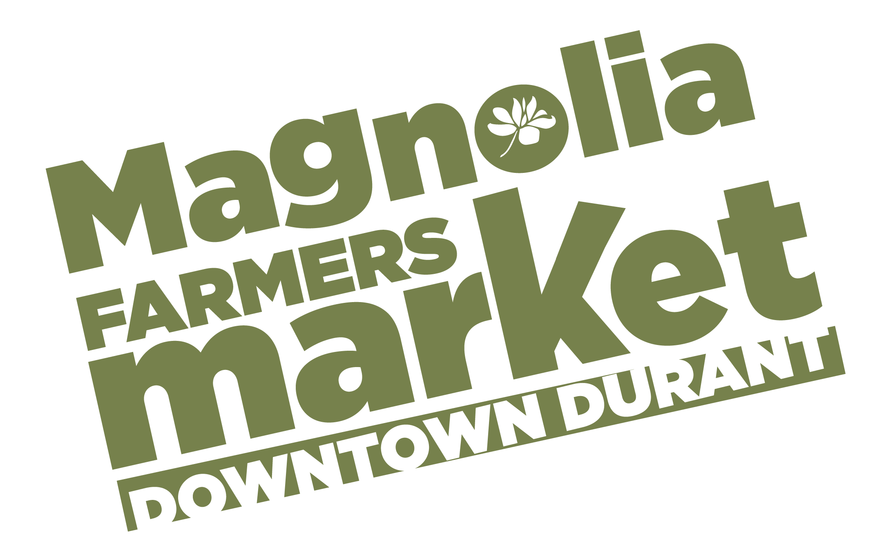
Vendor Application 2024
Vendor Name ________________________________________________________________________
Business Name _______________________________________________________________________
Address ___________________________________City_____________State_____Zip______________
Farm Address (specific location of land used for production) ____________________________________
____________________________________________________________________________________
Phone #_______________________________Second Number #________________________________
Email Address________________________________________________________________________
Website_____________________________________________________________________________
Facebook___________________________________________________________________________
Oklahoma Sales Tax ID#___________________________________________________________________ (Accurate reporting of sales to the Oklahoma Tax Commission is the sole responsibility of the vendor and is not monitored by the market.)
Number of 10’x10’ Booth Spaces Needed ________________ Current Permit Expiration date:________________________
List all items you intend to sell at the Market and where they are sourced: ________________________________________________
____________________________________________________________________________________________________________

____________________________________________________________________________________________________________
____________________________________________________________________________________________________________ (Additional items sold at the market must be approved by the Market Manager prior to sale)
I agree to sell the above listed items at the “Durant Magnolia Farmers Market”, Durant, OK and hereby apply for membership in the Durant Magnolia Farmers Market.
____________________________________________ ____________________________ Signature/Date
Signing this application indicates your agreement to abide by all rules listed in the Durant Magnolia Farmers Market Rules and Regulations.
Attach the $25 annual membership fee) to this application and return it to: City of Durant, 300 W Evergreen, Durant, OK. Make checks payable to City of Durant. Questions? email manager@durantmainstreet.org
Durant Magnolia Farmers Market
Rules and Regulations 2024

Rules and regulations governing operation of the “Durant Magnolia Farmers Market” will be determined by Durant Main Street in conjunction with the Farmers Market Vendor Committee.

Dates + Location:
The Market will be held on Saturdays beginning on Saturday, April 20, 2024 through Saturday, October 26, 2024 with no market Oct 19, 2024 from 8:00 am – 12:00 pm in Market Square at the corner of Evergreen and First Avenue.
Durant Main Street may cancel or relocate a market day when absolutely necessary due to other community events or inclement weather.

Who Can Sell:
- Vendors engaged in agricultural production or craftsmanship of hand crafted products and member of the Durant Magnolia Farmers Market. Vendors may become members of the Durant Magnolia Farmers Market by submitting an application and receiving approval from the Market Manager. Memberships may be limited at the discretion of Durant Main Street.
- In agreement with the Oklahoma Department of Agriculture, Food, and Forestry (ODAFF), 70% of vendors must be based in Oklahoma and 30% may be based in Texas.
- In accordance with ODAFF, our market will maintain a ratio of 80% farm/ranch/food specialty vendors and 20% craft vendors.
- Our goal is to promote locally grown produce and related products. With this in mind, produce vendors must grow 60% of their products on their own farm and up to 40% may be resell items (acquired, purchased, traded, or co-op from other vendors).
- Vendors are subject to seasonal farm visits from the market staff to verify products being grown locally. Dishonesty in advertising is grounds for dismissal from the market.
- Vendor exceptions outside of the local guidelines outlined above may be made based on overall product availability at the discretion of the current Farmers Market vendors. Supplemental Vendors who are an exception will be decided by a vote from current market vendors at an official Farmers Market meeting. If permitted for the market, supplemental vendors will receive guidance on supplemental items they are approved to sell.

What Can Be Sold:
- Fresh fruits and vegetables
- Fresh or dried herbs or flowers
- Honey, jams or jellies**
- Whole, un-cracked pecans, peanuts, other nuts or grains**
- Meats, fish, eggs and poultry**
- Bedding plants, bulbs, seed and other floriculture crops
- Crafts/Handmade Items
- Farm/garden tools and supplies

**Processed foods require a license from the State Department of Health.
**See Oklahoma Freedom Food Act.

Processed foods are agricultural products grown by the seller that have been processed, or any product, the sale of which a government agency regulates. Examples are milk, cheese, oils, vinegars, meats, poultry, eggs, honey, soap, and herbal preparations.

Agricultural products licensed, inspected or otherwise regulated by the federal government, the State of Oklahoma, Bryan County or the City of Durant may be sold only upon the Market’s receipt and acceptance of required documentation of compliance with those regulations.

Vendors must abide by all applicable federal, state and local health regulations. In addition, they must adhere to federal guidelines on labeling.

Supplemental Vendors:
Vendors who are voted in as Supplemental Vendors are only allowed to sell select items based on overall local product availability. Product availability will be determined on a monthly basis by the market staff by surveying local growers on estimated available local inventory. Market staff will provide supplemental vendors a list of produce acceptable to sell each month.

For local growers, the deadline to complete your estimated inventory list will be the last Saturday of every month. An estimated inventory survey will be dispersed and collected by the Market Manager. If you do not submit your list to market staff by the last Saturday of the month, your produce may be subject to competition with our supplemental vendors the following month.

Our intention is to eliminate unhealthy competition between local growers and supplemental vendors. Our continued goal at the Magnolia Farmers Market is to promote locally grown produce and products. We strive to give local growers preference, while creating a balance of supply and demand for our customers.
Food Trucks + Concessions:
Food trucks must pay the weekly Farmers Market fee in addition to obtaining a Food Truck Permit from the City of Durant.

Health + Safety:
- Watermelon and other produce must be sold whole. A cut melon may be shown covered for display only.
Restrooms and hand washing facilities are available.
- Produce to be washed, must be washed prior to arrival at the market. (Buyers should be informed that produce should be washed prior to consumption.) No alcohol or smoking is allowed during the market.

Insurance Requirements:
All vendors should carry General Liability Insurance to cover their operations at the market. Consult your insurance agent for advice. Durant Main Street and the Magnolia Farmers Market will not be held liable for any accidents occurring during the farmers market.

Fees + Space Assignment:
- Membership Application Fee is $25.00 for a 10x10 space, which includes the $25 farmers market permit from the City of Durant.
- Membership must be paid in full before vendor is allowed to sell at the market.
- NEW Weekly Booth Fees will be $10 per week per10x10 space.
- Stall fees shall be paid on or before the day of Market.
- The Market Manager may assign space on a first come, first served basis as needed. The assignment is for that market day only and may vary from week to week if the vendor chooses to be absent.
Market Day Setup Procedure:
- The Market hours will be Saturdays from 8:00 am-12:00 pm. Arrival and set up time on Saturday will be at 7:30 am and market payment is due at that time before market begins. All vendors will be ready for business on Saturdays by 8:00 am. Late arrivals will not be allowed to set up.
- Vendors are required to provide their own table or booth setup. 10x10 tents for shade are suggested.
- Every vendor will be required to post a sign including their vendor name, product, and area products are grown or made.
- Members will be in charge of keeping their space clean and trash taken out each market.
- For safety reasons, early takedown and departure before closing time will not be allowed. Exceptions may be made by Market approval.
- All Vendors will leave the Market no later than 1:00 pm on Saturday.

Attendance Policy:
Failure to attend market can result in losing your market membership.

Code of Conduct & Vendor Responsibilities:
- Vendors are expected to conduct themselves in a professional manner. Vendors will deal with the public, market staff, and fellow vendors in a positive, courteous manner.
- Market members will not slander or gossip about the market or fellow vendors, whether at the market or on social media.
- Pricing of same items between vendors must be comparable. Vendors found undercutting will be asked to adjust their pricing back to comparable pricing. Undercutting will be considered a violation of market rules.
- If you have a discrepancy regarding another vendor or market policies, you are required to bring your concerns to the market staff at Durant Main Street. Courtesy to others and our customers will prevail above all disagreements.
- Any vendor that violates this Code of Conduct is grounds for suspension or removal from the market. Market staff will base conduct decisions based on what we at Durant Main Street hear and see with our own eyes and ears. Hear say and tattle telling will not be tolerated.

Effect of Membership:
- By becoming a member of the Durant Magnolia Farmers Market, the member agrees to the terms of the Rules and Regulations of the Durant Magnolia Farmers Market.
- The member further agrees to permit field inspections of his/her farm or growing sites or crafters workshop, to assure compliance with the Rules and Regulations of the Market.
- As condition of the membership, the member agrees to release and hold Durant Main Street, its directors, officers, agents and employees harmless from all claims related to or arising from such membership.
- Durant Main Street reserves the right to prohibit anyone from selling at the Market.
- Members are expected to comply with government regulation that may be in effect for activities that take place at the Market. These include certification of scales, health rules applicable to samples and food display, statements about being organically grown, etc.
- Food Vendors are responsible for product liability insurance.
- Compliance with all codes and regulation of the County Health, Fire and Police Departments; the State Health and Revenue Departments; and the Center for Disease Control are required. These agencies have the final say in any dispute in the operation of the Market.
- Market members are expected to help market and promote the Durant Magnolia Farmers Market. Handing out flyers, passing out posters, posting on social media, and advocating the positive qualities and benefits of having a local market is encouraged.
- Vendors found to be in violation of one or more rules will be suspended from selling at the Market.
- Anyone who fails to comply with the Rules and Regulations may have their membership terminated with no refund of dues or fees.
For questions, contact:
Durant Main Street
580.924.1550
www.durantmainstreet.org | manager@durantmainstreet.org

JOIN THE FARMERS MARKET FACEBOOK GROUP:
https://www.facebook.com/groups/1822210474667675/
