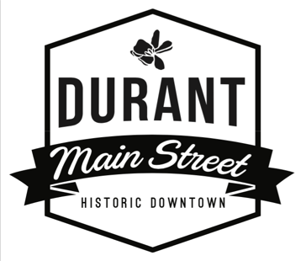
Durant Main Street – Board of Directors
Board Meeting Agenda
Vision Statement: Durant Main Street is the anchor of our community. Rich in culture and arts, locals and visitors alike are drawn for unique shopping, dining, and entertainment. Durant Main Street is a place where locally owned businesses thrive, history is preserved, and our friends and neighbors gather together to live their best life, locally.
Meeting Date: May 16, 2023
Meeting Time: 5:30 pm
Meeting Location: Durant Mercantile 124 N 2nd Ave Durant
- Call to Order
- Roll Call (2min)
- Consent Items (3mins)
  - May 16, 2023 Agenda
  - Treasurer’s Report
  - Approve minutes for April 18, 2023 meeting
- Announcements / Items for Discussion
City Contract
Budget
2023 Awards Banquet-committee/date/location
New Board Members-suggestions for voting in at next meeting
Bylaw Changes-Need to establish a committee
Permit wording for ordinance change
July Event
Fall Festival date needs to be set
Facebook Group
Main Street Mixer
Main Street Training
Chamber Board Meetings
August Coffee Network
Committee Reports
-Organization
-Economic Vitality
-Design
-Promotions
- Items for Consideration
- Old Business
Policy & Procedures Manual
Partnership Packets
- New Business
Facade Grant Application from Lost Street Brewing Co.
- Dates to Remember
June 1 First Main Street Mixer
June 1 Mornings on Main
June 16 & 17 Car Show
April 29 Magnolia Farmers Market/Maker’s Market
- Adjournment

