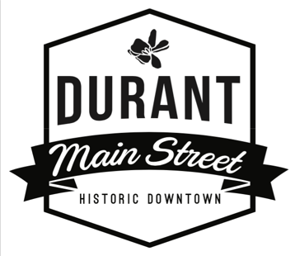
Durant Main Street – Board of Directors
Board Meeting Agenda
Vision Statement: Durant Main Street is the anchor of our community. Rich in culture and arts, locals and visitors alike are drawn for unique shopping, dining, and entertainment. Durant Main Street is a place where locally owned businesses thrive, history is preserved, and our friends and neighbors gather together to live their best life, locally.
Meeting Date: April 18, 2023
Meeting Time: 4:00 pm
Meeting Location: Durant Mercantile 124 N 2nd Ave Durant
- Call to Order
- Roll Call (2min)
- Consent Items (3mins)
  - March 23, 2023 Agenda
  - Treasurer’s Report
  - March 23, 2023 Meeting Minutes NEED OTHER MONTH’S MINUTES ASAP
- Announcements / Items for Discussion
City Contract
2023 Awards Banquet
New Board Members
Partnership Packets
Market Square Building
Landscaping Meeting with City
Permit Meeting with City
July Event
Fall Festival
- Items for Consideration
- Old Business
Memorandums of Understanding-Plan for that
Policy & Procedures Manual (2mins)-Found old copy and I am working on it.
Bylaw Changes-Need copy of old ones so I can start working on them.
- New Business
Office Signage
Merchant Meetings/Mornings on Main
Main Street Mixer
- Dates to Remember
May 5 Margarita Madness
June 16 & 17 Car Show
April 29 Magnolia Farmers Market/Maker’s Market
- Adjournment

