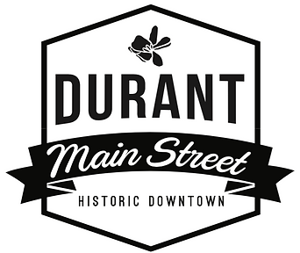
Complimentary Beverage License Reimbursement Grant
Durant Main Street will reimburse half of your Complimentary Beverage License fee (up to $50) upon completion of your participation in one Durant Main Street Sponsored Wine Walk.
Applicants can apply 1 time per year and must participate in at least one Wine Walk Fundraiser per year to receive the grant.
Applicants must be a Durant Main Street Member

Name:____________________________________________________________

Business Name:_____________________________________________________

Complimentary Beverage License # and expiration date:_____________________

Signature:__________________________________________________________

Please attach a copy of your Complimentary Beverage License.
We do recommend applying for your license as soon as possible as they take 6-8 weeks to process. Your application must not be completed on-line.

