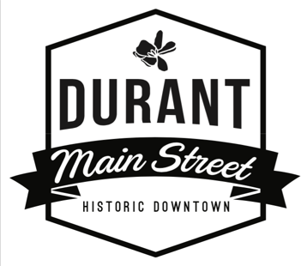
Durant Main Street – Board of Directors
Board Meeting Agenda
Vision Statement: Durant Main Street is the anchor of our community. Rich in culture and arts, locals and visitors alike are drawn for unique shopping, dining, and entertainment. Durant Main Street is a place where locally owned businesses thrive, history is preserved, and our friends and neighbors gather together to live their best life, locally.
Meeting Date: February 21, 2023
Meeting Time: 5:30 pm
Meeting Location: Durant Mercantile 124 N 2nd Ave Durant
- Call to Order
- Roll Call (2min)
- Consent Items (3mins)
  - Feb 21, 2023 Agenda
  - Treasurer’s Report
  - Jan 22, 2023 Meeting Minutes
- Announcements / Items for Discussion
- Old Business
  - Pulled Pork Fest and Car Show (5mins)-Need help calculating payout to car club and setting meetings for next year
  - Memorandums of Understanding
  - 2022-2023 Committee Action Plans
  - Committees and Committee Chairs-all member emails needed as well as meeting dates
  - Policy & Procedures Manual (2mins)-table for time being
  - Bylaw Changes-Linda has broken down and we will send out for member input
- Items for Consideration
  - New Business
    - Farmer’s Market Application
  - Old Business
- Dates to Remember
April 22, Lip Sync Battle

- Adjournment

